Esoteric Healing Client Intake Information

Name________________________________ Date__________ DOB_________ Phone__________________
Address______________________________ City______________________ State______ Zip_____________
Email________________________________________ Referred By:__________________________________
Occupation______________________________________ Employer__________________________________
Emergency Contact_______________________ Relationship_________________ Phone_________________
Primary Care Provider__________________________

Current Health
Today’s primary concern or goals: ________________________________________________________________ Other concerns or goals:___________________________________________________________________________
How long have you had the above concerns?___________________________________________________________
Classify your concern: Minor_____ Major______ Recurring/chronic______ Getting Worse______ Better____
Have you received treatment with a physician for this before? ________ Explain_______________________________
Past surgeries or Other related info:___________________________________________________________________
What activities has it affected? ______________________________________________________________________
Exercise activities: ______________________________ How Often? ______________________________________
Type of Diet? (regular or special) How much water do you drink a day?_______________________
Frequency of bowel movements? Regular Meditation or Spiritual Practice? Y or N
Check any of the following that apply to your current health:

Allergies/Sensitivities __ Arthritis __ Blood clots/DVT __ Cancer __ Circulatory Problems __
Contagious Diseases __ Diabetes __ Difficulty Breathing __ Seizures _ Headaches/Migraines __
Heart Conditions __ Osteoporosis __ High Blood Pressure __ Flu/Cold __ Kidney Problems __
Nervousness __ Pregnancy __ Skin/Fungal Conditions __ TMJ __ Varicose Veins __
Chronic/Acute Pain __ Sleeplessness __ Neck/Spine Injury __ Phlebitis __ Digestive Disorders __
Joint Discomfort __ Sciatica __ Decreased Range of Motion __ Neurological ___ Muscle aches___ Sprains __
Other Disorders/Issues __________________________________________________________________________
_____________________________________________________________________________________________
List any medications you are currently taking ________________________________________________________
List any supplements / vitamins you are taking:___________________________________________________________
List any current medical treatments you are receiving ____________________________________________________
List other self care / alternative therapies you use______________________________________________________
Mark on figures any areas of pain, tenderness, stiffness, swelling, discomfort or concern
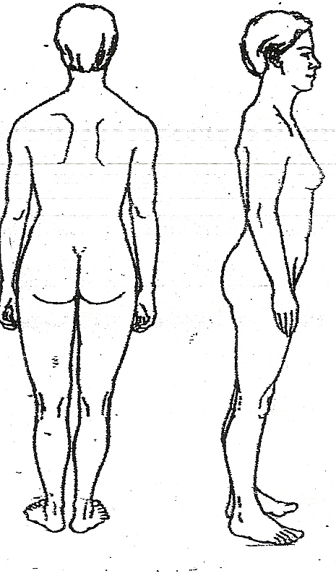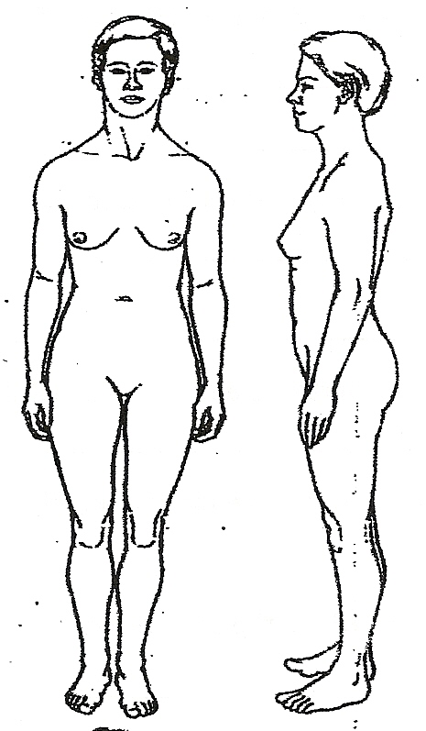

Consent for Care
I understand that Esoteric Healing is an energy therapy that works in the body’s etheric fields and is not a hands on session. I realize that it is a complimentary therapy and should not be construed as a substitute for medical examination, diagnosis, or treatment and that I should see a physician, chiropractor, or other qualified medical specialist for any mental or physical ailment of which I am aware. I affirm that I have stated all my known medical conditions and answered all questions honestly. I agree to keep the practitioner updated as to any changes in my medical profile and understand that there shall be no liability on the practitioner’s part should I fail to do so.

Client Signature __________________________________ Date __________________________________

